Windows: How to Remote Connect to Windows Computer using Remote Access Tool
2-Hour Time Limit
There is a 2-hour time limit when using Windows computer via remote connection. When there are 2 minutes left, the dialogue box below will appear. Once time is up, the remote connection will be ended, and all unsaved work will be lost. Please remember to periodically save work to OneDrive.
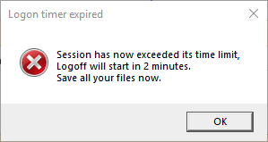
*Note: Please remember to periodically save your work.

The following document contains four sections. If you have already downloaded and installed VPN, then skip to Section 3.
Section 1: Download and Install VPN
Section 2: Setting Up VPN
Section 3: Remote Connect to Windows Computer
Section 4: Saving File Locally and Uploading/Downloading to Cloud Storage

Section 1: Download and Install VPN
- Open an internet browser and go to CalStateLA VPN to install VPN.
- Type in your MyCalStateLA ID credentials and click LOG IN.
- Download and install Windows 32/64-bit GlobalProtect agent.
- When Welcome window displays click Next.
- Click Next.
- Click Next.
- When software has finished installing click Close to exit.

Section 2: Setting Up VPN
- Launch VPN client by searching for GlobalProtect.
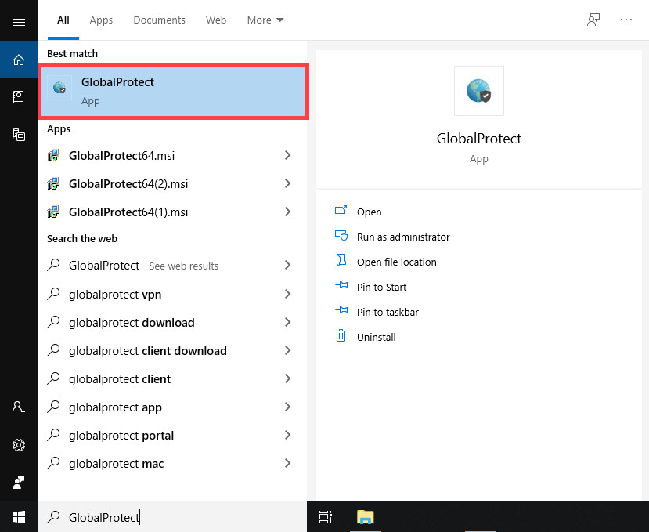
- Type in myvpn.calstatela.edu and click Connect.
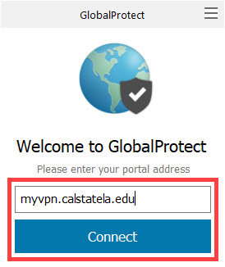
- Type in your MyCalStateLA ID credentials and click Sign In.
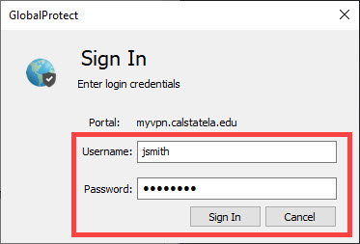
- You are now connected to Cal State LA Network via VPN. You may close GlobalProtect window.
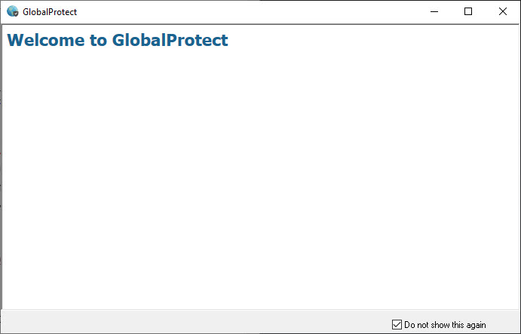

Section 3: Remote Connect to Windows Computer
- Open an internet browser and go to CalStateLA Remote Computer Access.
- On the left side of the page, select a Computer Lab.
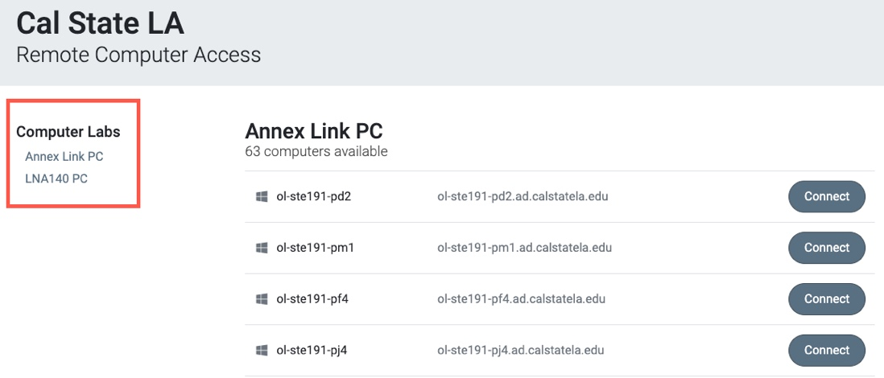
- Select an available PC and click Connect.
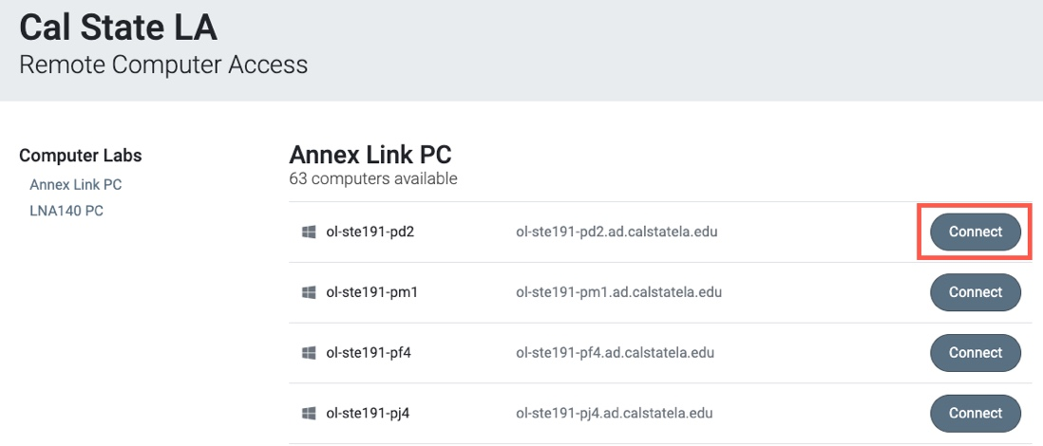
- Click Download Remote Desktop Protocol) file. When file has finished downloading, double-click to open it.
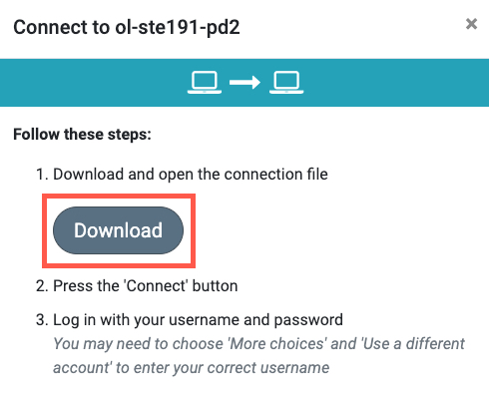
- Allow remote connection by clicking Connect.
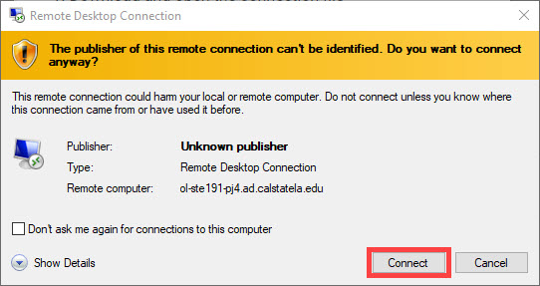
- Type in MyCalStateLA ID credentials and click OK.
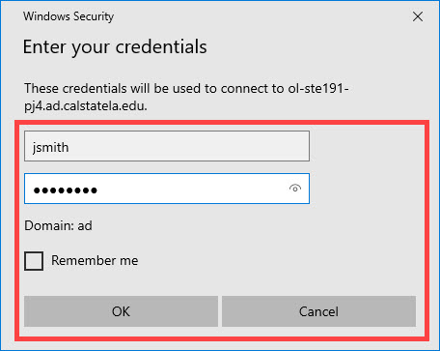
- You are now connected remotely to the computer.
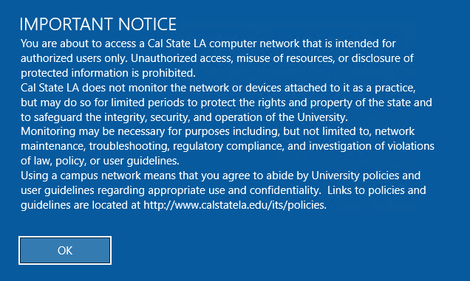
- To end remote connection, sign out of computer and close window.

Section 4: Saving File Locally and Uploading/Downloading to the Cloud Storage
*Note: Please remember to periodically save your work.
Saving File on Microsoft Office (Word, PowerPoint, Excel)
- To Save As a file, go to File > Save As > Browse > Documents.
  - File Name: Enter the name of your File
  - Save as type: Select the type of file you want to save as (Word Document, PDF, etc.)
- Click Save.
- The file has been saved into the computer’s Documents folder.
*Note: Many applications allow you to Save As, which allows you to specify the name and location of the file you are saving.
Upload File to OneDrive
- Open any browser and go to mymail.calstatela.edu
- Log with campus email and password.
- On the top left corner of the page, click the App Launcher and open OneDrive.
- Click Upload > Files > Documents > (Select your document) > Choose
- Upload time varies depending on size of file.
- The file is now uploaded to OneDrive and accessible on any device.
Download File from OneDrive
- Open any browser and go to mymail.calstatela.edu
- Log with campus email and password.
- On the top left corner of the page, click the App Launcher and open OneDrive.
- Select a file, then click Download.
- Download time varies depending on size of file.
- The file is now downloaded on your device.
*Note: Other cloud storage services include Google Drive, Dropbox, and Amazon Drive. Alternatively, the file can be sent via email as an attachment.

