CSU Learn: Completing Training
Spring 2020, Version 3

Curriculums
Curriculums are a type of Learning Activity in CSU Learn that require users to click Register before launching course content. Users who have been assigned courses may navigate to the Assigned Learning section of their CSU Learn dashboard to find all their assigned training. Curriculums are distinguishable by verifying the Activity Type, noted above the Activity Name (Figure 2). Alternate method users may find a Curriculum is by clicking a link shared by the administrator, which redirects users directly to the course page.
To register for and launch Assigned Curriculums:
- Visit the Portal and log in with your campus account.
NOTE: Firefox or Chrome browsers are recommended to avoid possible incompatibility of CSU Learn functionality.
- Once logged in, click the CSU Learn Quick Launch link.
- A new tab opens in the browser, and you are logged in to CSU Learn.
- Click the Assigned Learning section on the dashboard to view assigned training (Figure 1).
NOTE: If you have clicked a link, e.g., in an email or a webpage, and landed directly on the course details page, click Register at the top-right of the screen, and follow any necessary on-screen prompts. Then, click Start to launch the course modules (see Figure 3). After clicking Start, follow steps 7 and on to successfully complete the course.
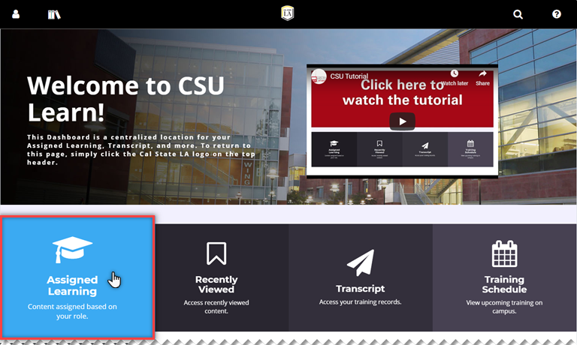
Figure 1 – Assigned Learning highlighted on CSU Learn dashboard
- The Timeline is displayed listing one or more courses assigned. Locate the necessary Curriculum and click the Register button (Figure 2).
NOTE: All assigned activities are located in the Learn and ALL sections of the Timeline. Some Activity Types may not require prior registration and can be completed by clicking Start for the respective course within the Timeline.
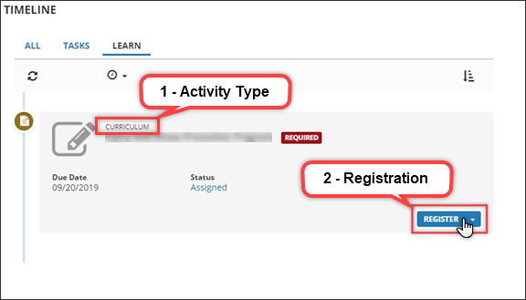
Figure 2 – User’s Timeline with a Register button highlighted for a Curriculum
- After registering for the assigned Curriculum, click Start to launch the course modules (Figure 3).
NOTE: Allow pop-ups on the browser to ensure the proper functionality of course modules and do not close the original CSU Learn browser window in the background; it is necessary to track your progress.
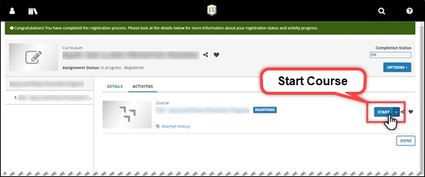
Figure 3 – Curriculum with Start button highlighted after registration
- The course launches in a new window. Proceed through the slides in the course, making sure to complete all activities, quizzes, and visit hyperlinks by clicking on them. When complete, be sure to check any acknowledgments at the end of the course.
- Once there are no more slides to click through, close the course modules. You are re-directed back to CSU Learn.
- A record of all completions is located in the Transcript on the dashboard.

